"Elba has been great from the very beginning. Only after joining and becoming an EAGLE myself did I realise how beneficial it is for young people. Being an EAGLE has helped me change as a person in many ways. Both professionally and personally. I think I have learnt more about myself than I thought I knew. The transition from university to full time employment through ELBA has got to be one of the best experiences I have ever had. The people I have met along the way are amazing; I do not see them as co-workers but as my friends 😊"
Shahnaz Akther – Rendall and Rittner

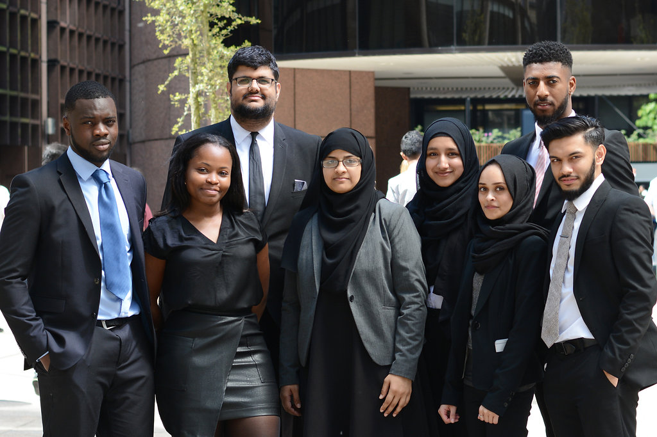"The Property Management Eagles Programme is an inspirational journey of its own! The intensive training provided by the National Theatre, Ashridge Business School and Pitman’s Training prepares you with the essential skills needed within Property Management. The two week Programme develops you as an individual (completely bringing you out of your comfort zone), leaving a professional that can take on the world. Along with the lifelong skills, you inherit lifelong friendships and the dedicated support of the ELBA Team. A truly memorial experience one will never forget!"
Alima Begum – Rendall and Rittner

“My experience of the property management Eagles programme was spectacular. I was not sure what to expect coming in but I have had nothing but positive experiences and some very life affirming lessons with ELBA"

"Regardless of what may happen going forward, these memories are ones that will live with me for a very long time"

"The quality of training provided by ELBA is top notch, extremely comprehensive and I could heartily recommend it"

"I have never felt so encouraged in a workplace environment up until this point and with this programme I have felt a raft of encouragement and support that has been wonderful and long may it continue"
Hassan Akbar – Rendall and Rittner

'The Eagles programme has helped me discover a side to myself which I never knew existed! The confidence I gained from this programme has been immense and allowed me to get out of my comfort zone, while meeting amazing people along the process! It has enabled me to embark upon an exciting journey and kick start my career in the field of property!'

Rizwan Mohammed – Rendall and Rittner

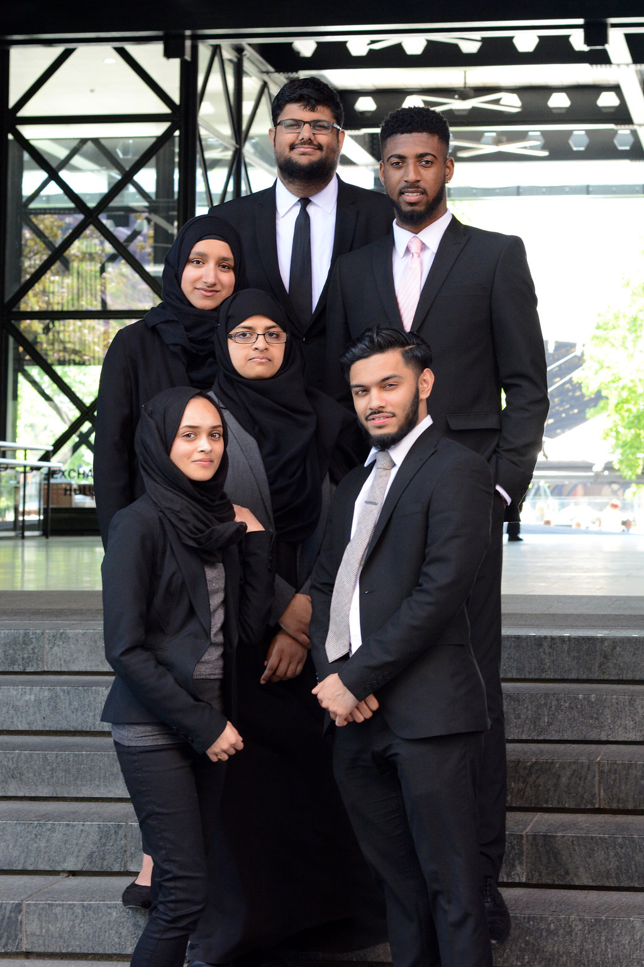"Being an EAGLE means being integrated into a support system that only gets sturdier with time - whether it's the ELBA staff (shoutout to Sally, Samsul and Holly) or my fellow EAGLES, who are now certainly my friends. I have gained invaluable training, friendships and experiences that I know will stay with me long after the programme is over. The placement itself is not 'a walk in the park' but I am using the challenges, to help me develop both personally and professionally which is something ELBA caters for extensively."
Smera Nadeem – Rendall and Rittner

“Being on the eagles programme really helped me come out of my shell. The training encouraged me to be more confident in myself and allowed me to find my strengths. I learnt that it isn't always about being competitive with each but to as a team to achieve a common goal.”
Anthony Hanchard – Rendall and Rittner

“The Eagles programme has helped me to build my confidence and has allowed me to embrace my flaws. The Property Management Scheme has opened my eyes to a new world, where the possibilities are endless. The training provided is outstanding and unique. The range of skills I have learnt I will remember forever. I am very fortunate to have been through this process and I would gladly do it all again.”

Kenneila Quashie – Broadgate Estates

"The ELBA Property Management Scheme is an unbelievable opportunity to take your first step in the industry, no matter what your background is. I am very grateful that in this short period, the scheme has provided transferable training and development that has empowered me to gain more confidence and to realise my potential."

Kevin Baffour-Awuah – Broadgate Estates

